
White Spire School
Spring Term

Dear Parents and Carers,

As we are coming to the end of the term, it is nice to reflect on all the hard work that has been seen over this term by governors, staff, pupils, parents and our partners in the local community.

Over the course of the term there has been many amazing events and activities going on in and outside of the school. The sixth form pupils continue to run a café at the Sapling centre where they are able put the skills that they have learnt into practice.

There have been a variety of class trips which include the cinema, bowling and DofE walks. In school there have been coffee morning, online safety theatre show, flower arranging as part of careers week and a bird experience.

Within the next term, there are many more trips and fun activities, these will include sports week, prom, school BBQ and a range of reward trips. Further information for these will be provided closer to the time.

We also look forward to our new music stations, outside seating that was selected by the school council and an updated school website.

Thank you to the three parents who put their name forward for parent governor. Congratulations to Dave Masterson and Debbie Thompson who are your chosen candidates. We look forward to welcoming you onto the governing board.

I hope you have a lovely break.

Michelle Bartle (Headteacher)

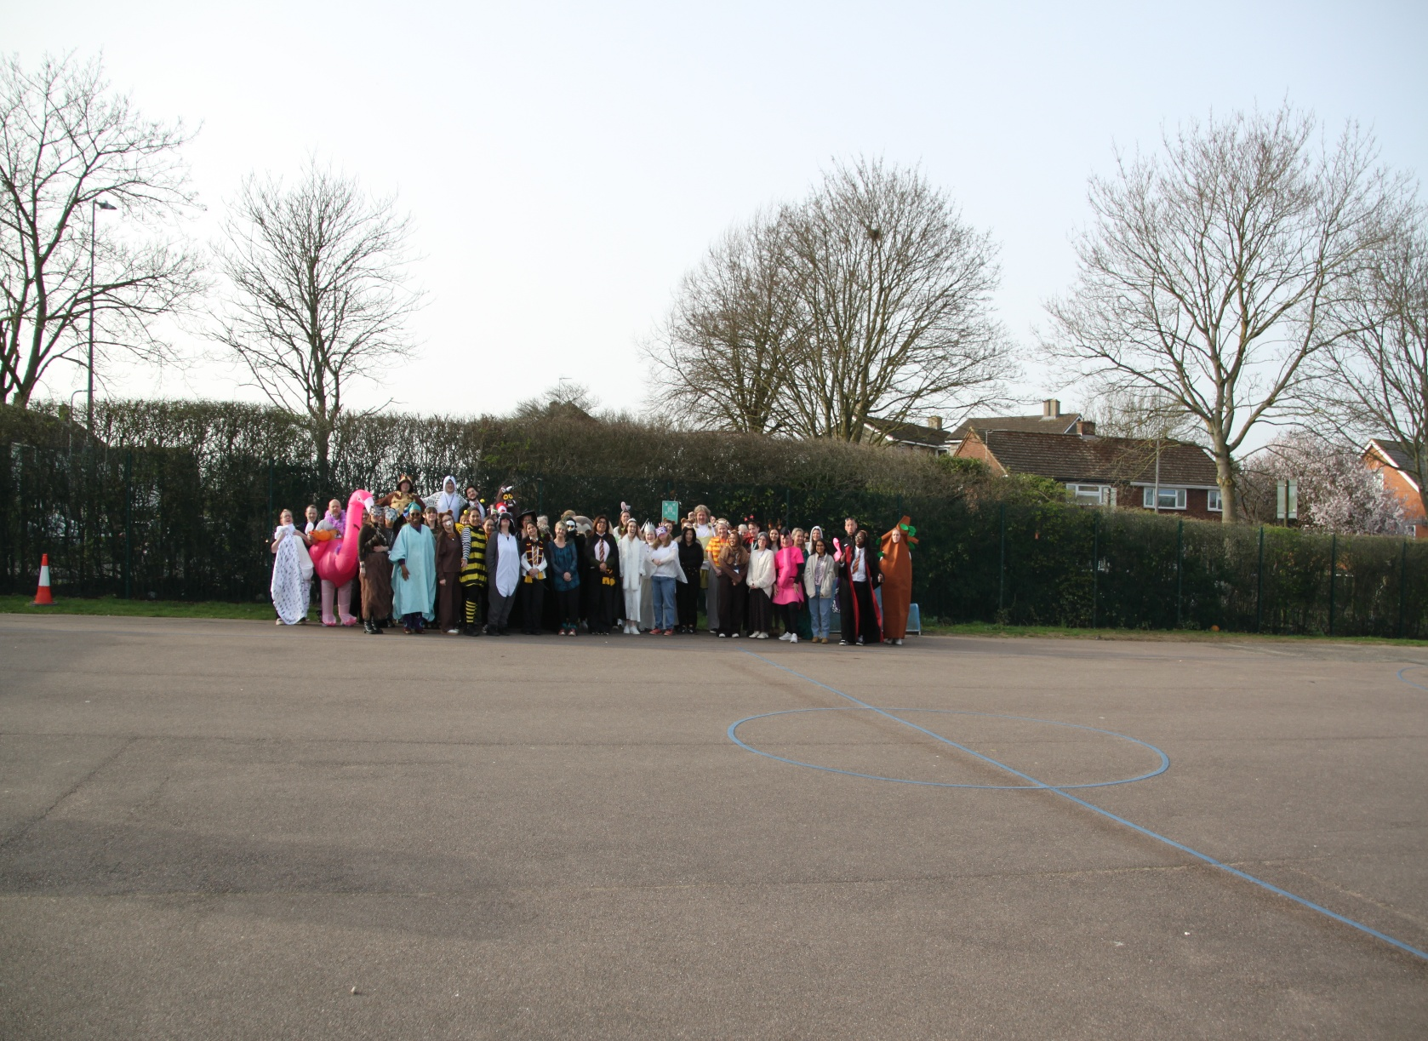
Medical Information
If there is a change in your child’s medical circumstances, can you please complete a new medical form.

Clubs
The school offers a range of lunch and afterschool clubs. Lunch clubs include a range of sports activities, drum club and Ragdolly Annas. The afterschool club form comes out termly for you to book your child on.

New school admins email address

The school has moved across to a new email system. The new email address is

admin@whitespireschool.org.uk

Curriculum

Our curriculum offers the pupils the balance of developing and securing everyday life skills, combined with the awe and wonder of exploring the world around us and new skills.

All curriculum documents of what is being covered each term can be found on the school’s website.

Online Safety

As you may have seen in the media recently, there have been reports of some incidents involving young people being organised through mobile phones and social media.
We kindly ask parents and carers to remain vigilant and to regularly check in with their children about how they are using their phones and online platforms.
Thank you for your continued support in helping keep our young people safe.

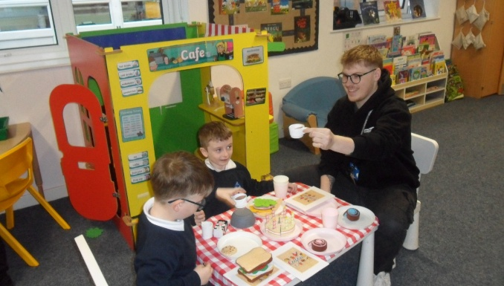
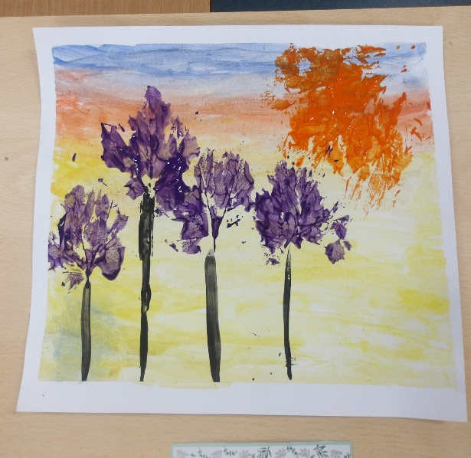
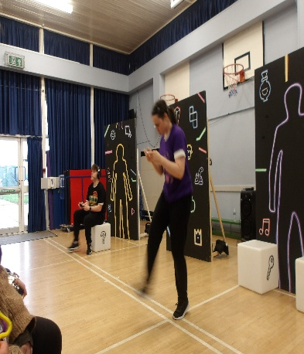
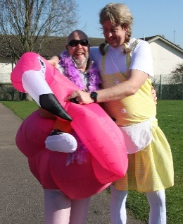
Safeguarding

For useful links and support please go to the school’s website and look under documents-safeguarding.

Our helpful safeguarding team are also on hand. Please contact the school if you need any further support.

Summer term
Can we please ensure that pupils bring in hats, water and have sun lotion on in the warmer summer days.

Important Dates

- 19th May Mental Health Curriculum Day
- 10th June Class 2, 3, 4, 5,6,7, 8 & 9 parents evening
- 17th June Class 1, 10, 11, 12, 13, 14, 15, 16 & 17 parents evening
- 19th June class 14, 15, 16 & 17 coffee morning
- 26th June Prom and leavers day
- 29th June sports week
- 2nd July Sports day
- 7th July transition day
- 16th July school BBQ
- 17th July last day of term
Further information will be provided closer to each event.

Forthcoming Whole School Events:

