SAFEGUARDING CHILDREN
Safeguarding and promoting the welfare of children is everyone’s responsibility.

Safeguarding is protecting children from maltreatment; whether that is within or outside the home, including online preventing the impairment of health or development; promoting the upbringing of children with their family, whenever possible and where this is in the best interests of the children. It is taking action to enable all children to have the best outcomes.

If you have any concerns regarding a pupil or staff member, can you please report to, however trivial.

Who to report to?
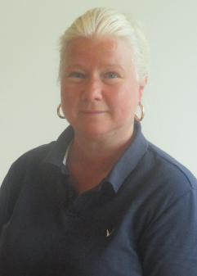


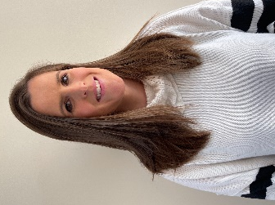

Sophie Lunnon
Learning Mentor
Designated Safeguarding Lead

Anton De Beer
Deputy Head
Senior Designated Safeguarding Lead

Michelle Bartle
Headteacher
Deputy Designated Safeguarding Lead

Laura Halsey
Deputy Head
Designated Safeguarding Lead

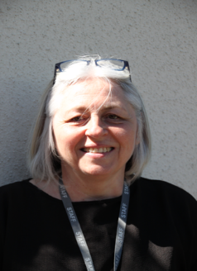
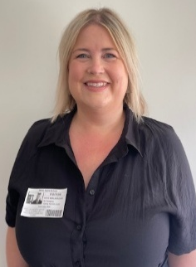

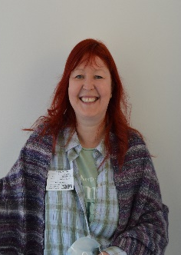

Katie Marlborough

Designated Safeguarding Lead

Gill Stock TA Lead Designated Safeguarding Lead

Tanya Stevens
Safeguarding Governor
Karen Richards
Medical Lead
Designated Safeguarding Lead

